
OOGD Declarations
User Manual
version 1.0: 2016/November

 | File Name: OOGD Declarations Manual | USER MANUAL
 | Title: OOGD Declarations Manual | Date: 2016 November
 | Author: Katharina Walgraeve | Status: Final
 | Author: Katharina Walgraeve | Version: 1.0

Table of Contents
Table of Contents 2
Document History 4
Revision History 4
Quality Review 4
Approval / Sign-off 4
Attention Icons 4
GENERAL SYSTEM OVERVIEW 5
Key Benefits 5
Background concepts 5
Access security 5
TO BE 6
INTERNAL USERS 7
View 7
Updates 11
Filter possibility 14
NOTIFICATION AND REMINDER LOGIC 15
Notification on the portal 15
Reports 17
UTL LETTER 18
SUPPLIER ACCESS 19
UTL template 22
Upload U.T.L. / Upload other document 22
Declaration overview 23
Validation rules on the portal 24
Log of changes 25
Printing and downloads 25
1.1.1 Proposed process new suppliers 26
2. Technical analysis 27
ADMINISTRATION 36
Appendix 37
Glossary of Terms 37
Additional supporting / reference documentation 37

Document History

Revision History
Author | Version | Rev. date | Summary of Changes | Section | Page
Katharina Walgraeve | 1.0

Quality Review
The following have been nominated as quality reviewers for this Product:
Name | Title | Date of Issue | Versions

Approval / Sign-off
This document requires approval from the following individuals:
(Signed approval forms are filed in the quality section of the project files)
Name | Role | Date | Signature

Attention Icons
The key below explains what each of these icons means.
Call-out: Important information the participant should be aware of.
Note: Information for the participant to consider for the learning activity.

GENERAL SYSTEM OVERVIEW

Key Benefits
The supplier portal is a tool to collaborate with our main stakeholders.
Since AG/CE suppliers were already declaring country of origin for the company, we extended this functionality also for IF3 and POWERSAP EMEA (CV and PT EMEA systems) and included the declaration of referential zones. Functionality is harmonized for all segments and all in scope suppliers to have 1 consistent screen on the portal, indifferent of processes behind it.
Screenprints in this manual are taken from the CSCN test environment https://stg-cscn.cnh.com/

Background concepts
Origin is the "economic" nationality of goods in international trade.
There are two kinds, non-preferential and preferential.
- Non-preferential origin confers an "economic" nationality on goods. It is used for determining the origin of products subject to all kinds of commercial policy measures
- Preferential origin confers certain benefits on goods traded between particular countries, namely entry at a reduced or zero rate of duty.
For export of assembled goods, the preferential origin of supplied components is needed to calculate the correct COO for the exported object, the origin of goods is used by NAFTA for bearings and AFTERSALES to create the PDF to request the official document of chamber of commerce (AG/CE only)
The Purchasing Portal will play the role of ‘collector’ of the supplier’s OOGD declarations for CNH Industrial.
Ongoing there will be daily updates of the data so that the portal always shows all the active parts. Suppliers can at all-time enter the portal and change the OOGD, there is no weekly process. The purchasing legacy systems take ownership of the updates done by the supplier on daily basis.
Specific for CV/PT there will be a YEARLY process with new protocol in YEARS.
Scope is IF3, Powersap EMEA and WPS.

Access security
The new purchasing mapping will be used for COO management. This mapping takes the login IAM groupcodes mapped to the harmonized vendorcode in WPS. The portal then knows all translations to the purchasing codes used in IF3 and Powersap to interface back and forth with those systems, but for a supplier we will handle only 1 vendorcode.
Internal users can see all information by searching on vendorcode, and can update all data. Only internal users, may check on the portal if each supplier vendorcode had users linked to it to notify the need for OOGD entry. Only an internal user can push the button to start the notification process.
External users need to be mapped and need to have the correct role OOGD compiler to be able to goto the module.

TO BE
Due to the different systems handling the master for OOGD, the process for CV/PT is slightly different from AG/CE
AG/CE | CV/PT
Owner of data WPS | Owner of data IF3 and Powersap EMEA
Based on active requirements linked to delivery schedules | Based on open orders with active movements in last 12 months (filter in backend systems); interfaced in yearly process
Continuous update process; only 1 record per part continuous updated with latest declaration, no protocol years; always show all zones; only 1 part for both spareparts and direct material | Yearly protocol process; each year protocol ID per partnumber; at November timeframe there can be 2 years active, so 2 records for each part
Key info is supplier, partnumber | Yearly bundle of OOGDS by year, gruppo societario (including type spareparts or direct), supplier, partnumber)

For both :
- 3 years of history to be kept
- Input data required
  - Country of origin
  - Preferential zones (9 ZONES )
  - Name / email of last certifier (given by the legacy system in the interface)
  - Date of update
- Portal only shows the latest valid OOGD declarations
- Daily interface to keep both ways systems updated, but for CV/PT only the yearly process will send the new protocol years and active parts to be validated

INTERNAL USERS

View
GOTO https://supplier.cnhind.com/supplier/ you will arrive on the homepage of the portal
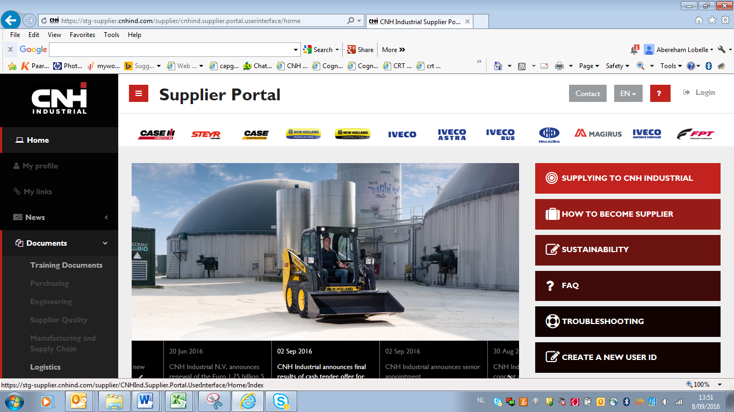
Goto right top to logon with normal userID and password as used on the network.
Goto the left menu : MODULES, PART MASTER DATA, Origin of Goods Declarations
The other link Oogd Certificate is the replacement of the former PDF print for spareparts. AG/CE aftersales uses a PDF print for formal request to Chambre of Commerce of the official COO declaration.

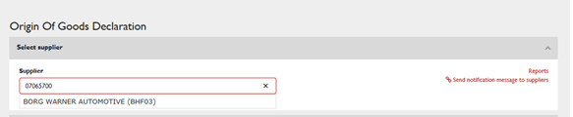
Start typing either the NAME of the supplier, the harmonized vendorcode or the sector vendorcode; this will immediately show a limited list of possibilities while typing.
Click on the presented name of your choice.
This will immediately show you the OOGD protocol data from IF3, PS and WPS in one screen based on the harmonized code :
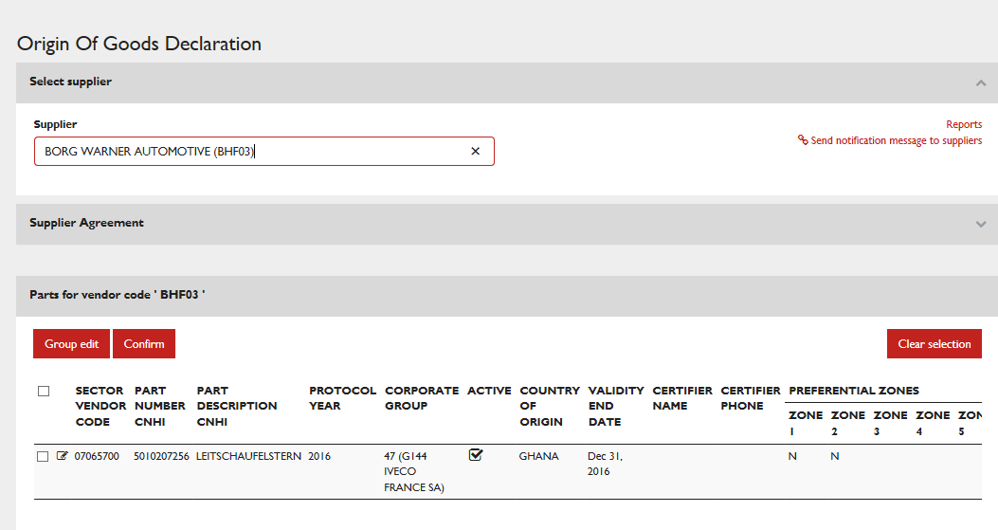

The system will give you an overview for this vendor on all his active partnumbers for all segments
CHANGE : ADD ORDERING
How do you want this ordered by (please chose) :
- Order by SECTORVENDORCODE and PARTNUMBER this will group all AG/CE, CV and PT together
- Order by PARTNUMER this will group all same partnumbers together independent of segment
- Order by PART DESCRIPTION this will group all similar parts together independent of segment
Fields explained :
- Sector Vendorcode (the management in the previous screen is based on harmonized code but we show in the detailed screen the translated code(s) from the other segments)
- Partnumber CNHi
- Part description
- Protocol year
  - For AG/CE this will always be the CURRENT year; there will be only 1 record for each partnumber
  - For CV/PT this will be the PROTOCOL year, in November there can be 2 years for 1 partnumber
- Corporate group : this is the Gruppo Societario interfaced from IF3 /PS, will be empty for WPS data
- Active : the active flag send by the legacy systems; the user can update this flag if a part is not actively delivered any more
- Country of Origin : the country of origin how it was declared in the previous declaration or empty if a new part
- Validity date (end date) = YEAR only as always 31/12; filled in when updated by the user;
  - For AG/CE it will be always current year when saved by the user
  - For CV/PT it will depend on the PROTOCOL year, but the user can enter up to 2 years validity in the detailed screen
- Certifier Name : interfaced by legacy system (the certifier is not necessarily the same as the OOGD compiler that enters the data)
- Certifier Phone : interfaced by legacy system
- Preferential zone 1 up to 9 zones in the interface 20 are foreseen for future changes

Updates
All internal users can update data on behalf of the supplier in the portal.
The updates can be done line by line or in mass update by selecting and clicking groupEDIT
1 line :
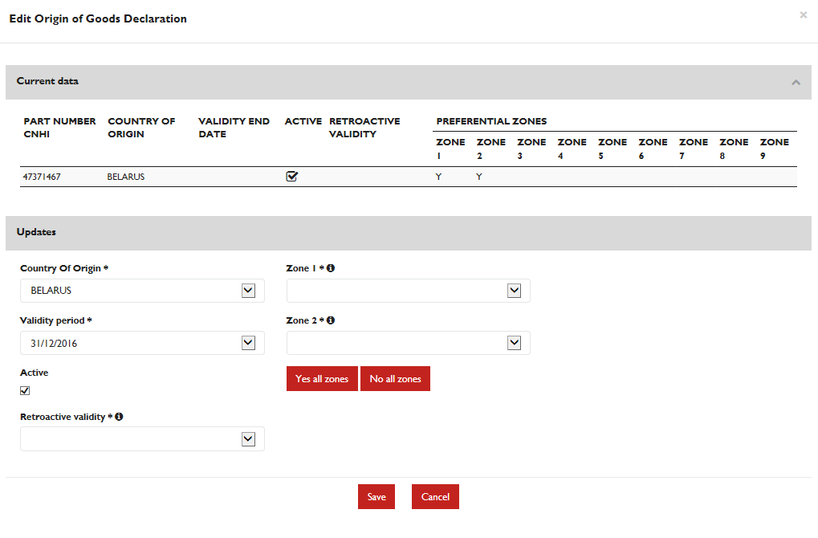
2016 : only zone 1 and zone 2 to be entered
2017 : all zones to be entered; in the interface zone 1 will become Zone 3, etc… to distinguish versus the 2016 situation
The user can update :
- the country of origin (dropdown of all countries)
- Validity period : default end of year, can be changed to next year end of year
- Zones : yes / no, default empty, mandatory to be filled in
- Retroactive flag : default empty, mandatory to be filled in; defines the declaration is valid from 1/1/xxx to the date of the declaration and a second declaration from the date of the declaration to the end of the validity date
AG/CE data coming from WPS does not have a PROTOCOL YEAR which means that during 2016 there will be 2 zones, while from 2017 on there will be 9 zones.
CV/PT data coming from IF3 and PS EMEA will have protocol years, which means that partnumbers will be once added for 2016 with 2 zones entry possibility, and once for 2017 with 9 zones possibility to enter.
At SUBMIT, the system gives ac onfirmation screen to make sure the declarations are entered both for the COO and for the preferential zones.
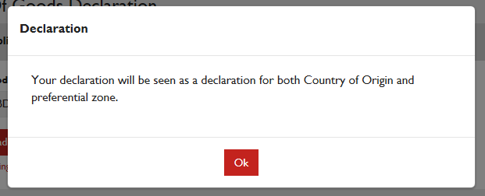
Selection of lines :
Select the lines clicking on the checkmark fields before each line and click on GROUP EDIT.
Will show the data of all selected lines, with the possibility to update for all lines in one go.
It is not possible to do a group edit over multiple protocol years data.
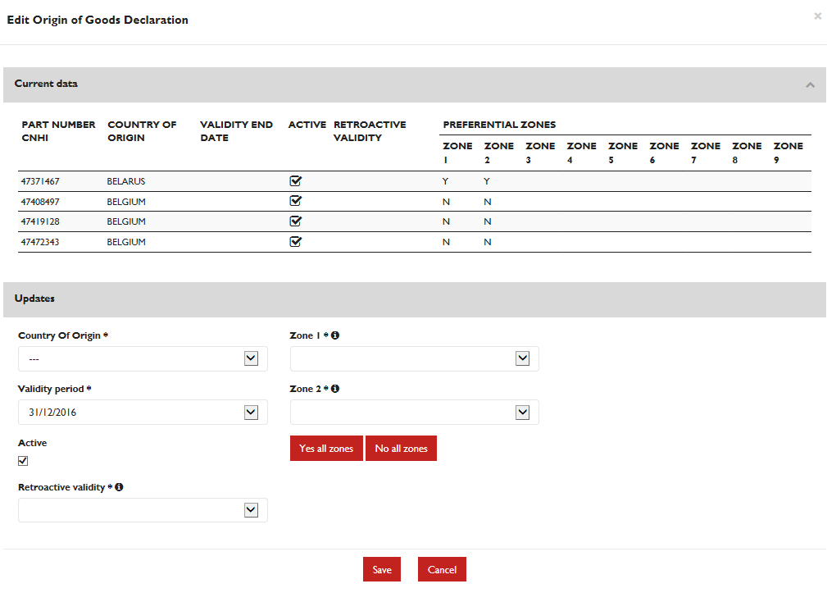
The active flag will be by default ON, zones by default empty, retroactive by default empty and all mandatory to be filled in. The previous validity end date that the system knows for AG/CE will be filled in, in the grid.
If the supplier delivers always the same parts and just needs to confirm the same entry in a new validity year, he can also simply push the button CONFIRM instead of GROUP EDIT.
The confirmation works also on the selected lines.
The system will give a choice window if the declaration is to be confirmed for the current year or the next year.
This determines the validity year end of current year or end of next year, but for the same protocol year as selected
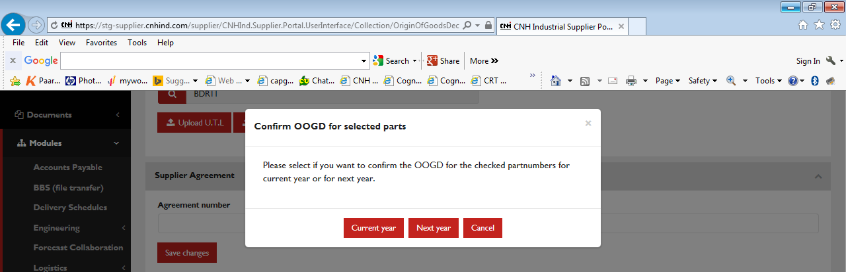

Filter possibility

Below the overview screen there is a FILTER section :
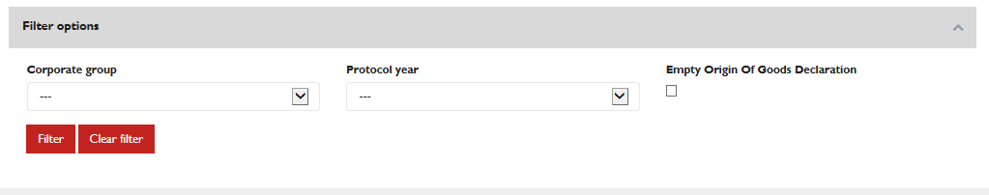
Filters explained :
- Corporate group : this is the Gruppo Societario as interfaced by IF3 and Powersap. For WPS data AG/CE this is not filled in; for CV/PT data the user can select
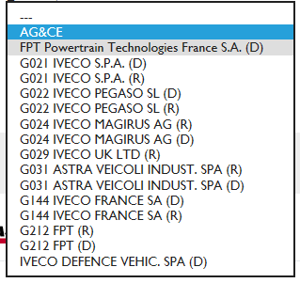
The Corporate group also contains the AG/CE choice, to make sure we don't exclude the WPS data that does not contain any corporate group information.
- Protocol year : the user can limit the view to only validate for current protocol year or only validate for next year; for AG/CE it will be always the current year as protocol year
- Empty Origin of Goods declarations : this will filter the view on only the records that need a validation :
  - If validity end year is empty or < 31/12/YYYY (need to be empty in the yearly interface from SAP systems)
  - WPS data : will always have the latest validity date : it will not be shown (so empty) in case the data is smaller than the today date) to be consistent with the CV/PT data

NOTIFICATION AND REMINDER LOGIC

Notification on the portal
The functionality is available throughout the year to declare OOGD’s on the portal.
Nevertheless at some point when the yearly declarations need to be given, the internal user will be able to start a NOTIFICATION process by clicking a button on the COO screen within the portal " Send notification message to suppliers" :
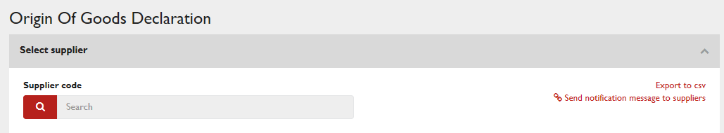

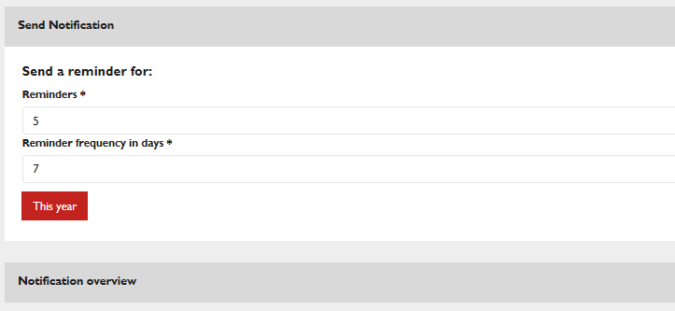
Reminders : how many reminders do you want to send
Reminder frequency in days : each how many days you want to send those reminders ?
In the above example every week there would be a reminder send for 5 weeks in a row.
The reminders are only send to the user within the role of OOGD compiler;COUNTRY OF ORIGIN COMPILER roles users
If a contact is added in the CONTACTS area, he will automatically get the OOGD compiler role. If the OOGD compiler role is added, he will not necessarily be the CONTACT, so mails send out to OOGD compiler roles.
CHANGE: add a report to show to whom the mail was send out
Mail format send out example
BUG FIXING ongoing
- Register the start of the notification process (keeping the user that started it, the date when it was started
- Show online the different notification periods
YEARLY PROCESS

Startdate | User that started | Validity year | #reminders | Reminder frequency in days | Last reminder
22/03/2016 | VB325 Katharina Walgraeve | 2017 | 5 | 7 | = start date + frequency x reminders

- Send out email notifications to all COO COMPILER roles (mail text to be defined); copy COO CONTACT; unique mail per compiler with link; only to suppliers that need to give a declaration (based on the data)
- Send X reminders (X to be defined); every X days (X to be defined)
- After the amount of reminders have been send, stop the notification cycle (add in the database)

Add clear warning that mails will be send out to suppliers !! YES / NO to continue

If another internal user clicks the button to start the notification process, the system will check if a process is already ongoing or not :
- If ongoing : show the user name
- If not : start the process

Any internal user can
- Check the vendors that don’t have a COO COMPILER ROLE (report)
- Extract the COO information, filter the extract on the ones not validated

Reports
On the homepage of the application, right side there will be a link to REPORTS, bringing the internal user to the following screen :
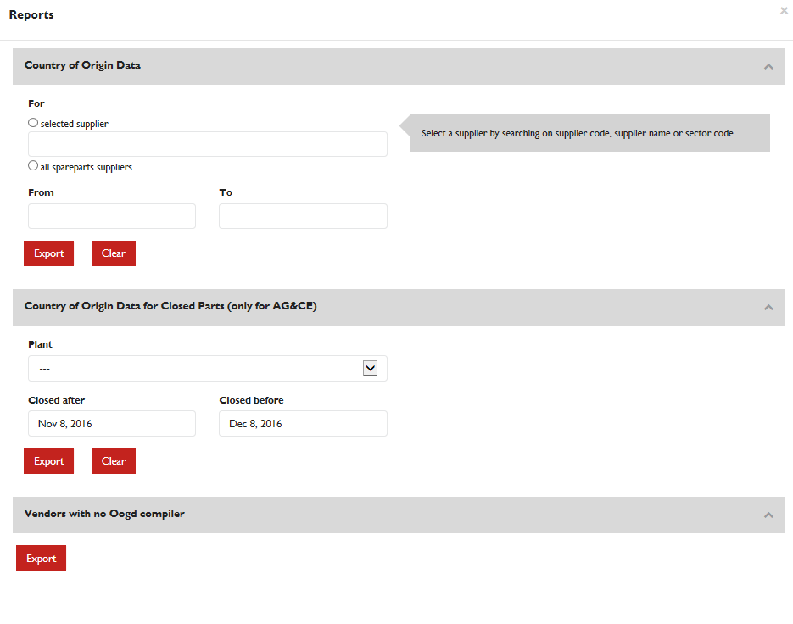
The internal user can download in excel data related to OOGD declarations for a certain supplier and period, for all spareparts suppliers, and for closed parts within certain period (spareparts AG/CE functionality).
The download VENDORS WITH NO OOGD compiler will have to be checked at each yearly process to understand for which vendors NO NOTIFICATION will be send out due to lack of users related to the vendorcodes. In this case a special exercise is needed to send out a communication to contacts of those vendors asking them to assign an OOGD compiler for their company.

UTL LETTER
The internal user can upload the UTL letter on behalf of the supplier
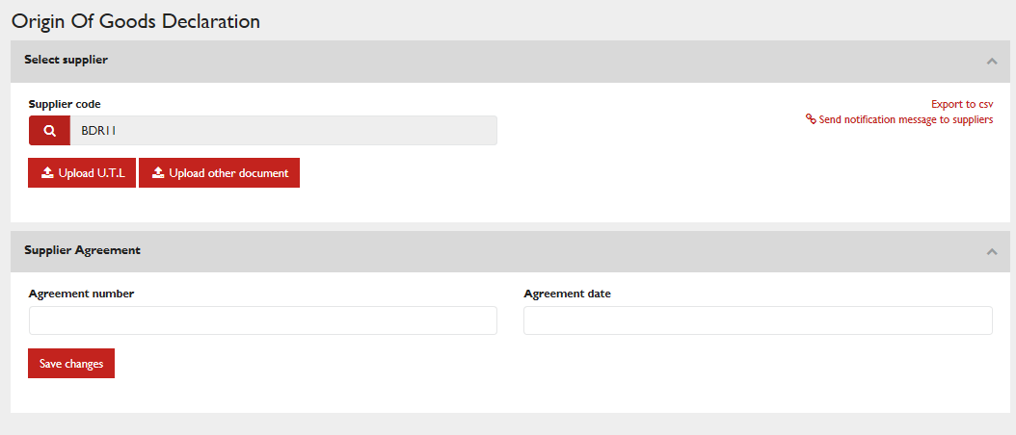
Click on Upload U.T.L. , this will move you to your browser where you can select a file.
Same for any other document linked to this supplier.

Oogd Certificate

By uploading a TXT files with parts, the system will search for the declarations :
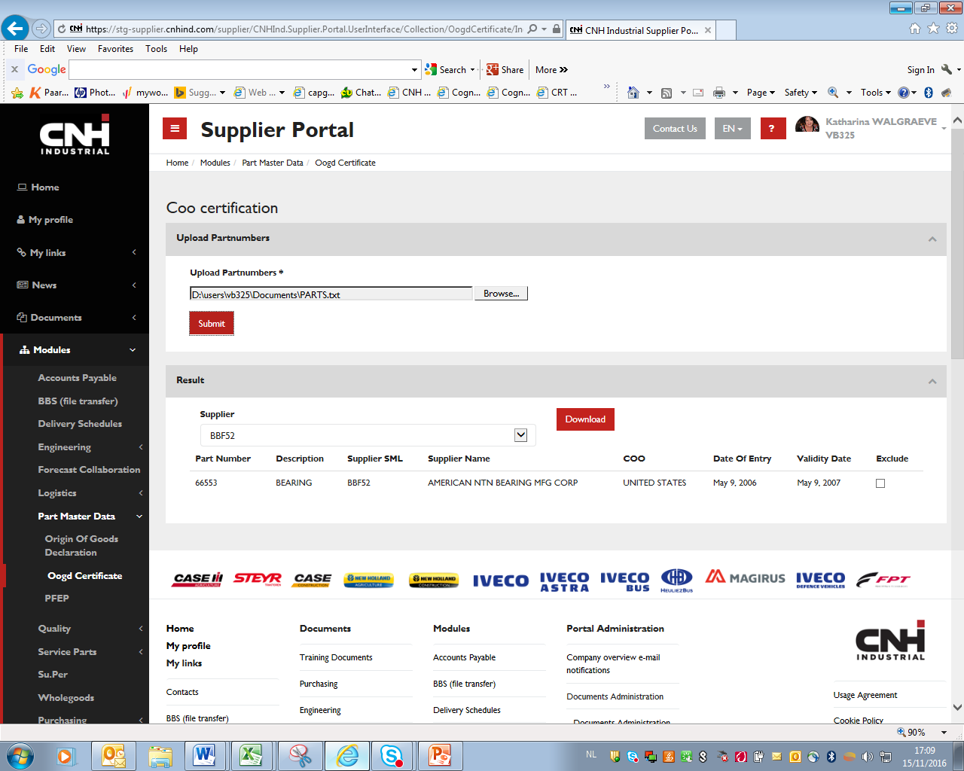

Then out of the list you can select the vendor that is delivering this part, for which you want to print the certificate.
If many parts, you can still EXLUDE before downloading the PDF certification.

CSV export

As internal user, you can click also on the link in the right corner : Export to CSV
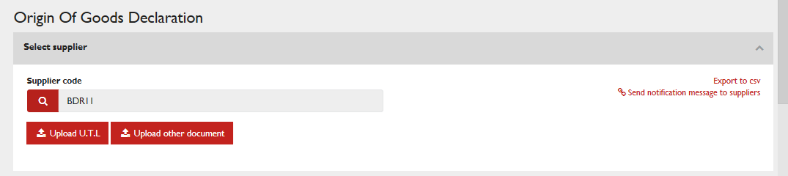
This brings you to the following screen :
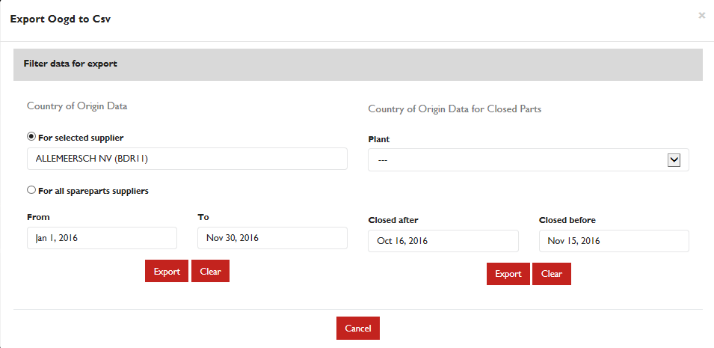
The left side is exporting COO data and zones updates for a selected supplier and period. This works for all segment data. Either select a supplier in the field or click all spareparts suppliers.
Always fill in a supplier and period or click spareparts and period
- spareparts is known for AG/CE because of the link of WPS with the delivery schedules, based on the plantcodes; but the declaration for AG/CE is for both the same
Spareparts is know for CV/PT because of the corporate group, some corporate groups are for spareparts, others for direct material; the declaration can be different
The right side selects the COO extracts for CLOSED parts;
this works only for the AG/CE side.
Spareparts users wanted to have a means to check also on the data for parts that were not any more on the delivery schedules screens because they work with closed orders. (shipments that were already shipped, order closed, but still COO data needed).

SUPPLIER ACCESS
As soon as the CONTACT for OOGD is entered in the contacts gathering screen, and it is a registered user, this user will be given the role of OOGD compiler. Only OOGD compilers will have the active link for the OOGD; any supplier user can request OOGD COMPILER role by mail or by MY PROFILE /functional groups, after which an email will be send to the supplieraccess@cnhind.com access management team that will provide the access.
Once access is given, the supplier user can see the link active in the menu :

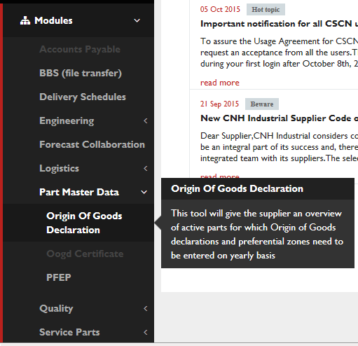

The first page of the OOGD declaration module will present the user with a dropdown box of all harmonized vendorcodes he is mapped to (purchasing mapping) :

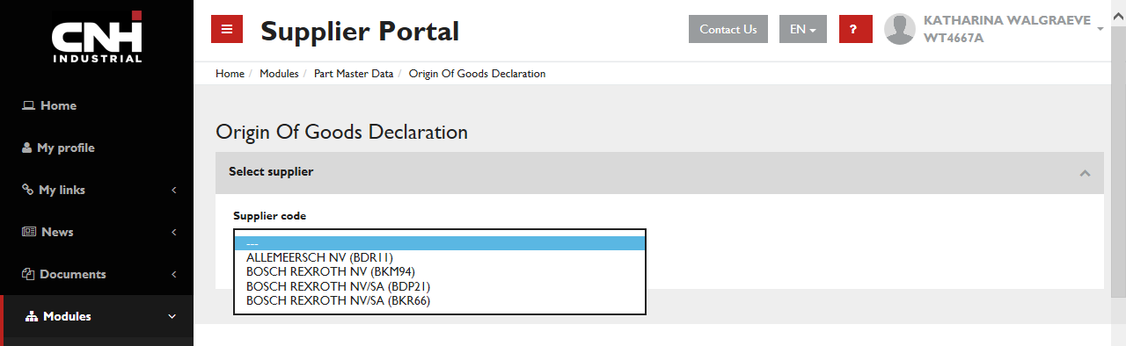
For each of them he needs to enter the OOGD information.
Before the process of electronical OOGD updates can start, we need to have a signed agreement from the supplier that he will be electronically updating the OOGD information. Today CNHI did not start this process yet.
When the user selects a vendorcode, the system will check if there is a signed UTL letter uploaded. If not, the system will present a screen to upload one.
The uploading needs to be done on HOLDING LEVEL, it means if the user uploaded a letter for an SML, it is also valid for the SML within the same holding. TO BE TESTED STILL+ NO ONGOING PROCESS YET ON HOLDING HARMONIZATION
The system will also provide the Country of Origin and Referentialty CONTACT type user, which is the user that fills in the declarations for their company.
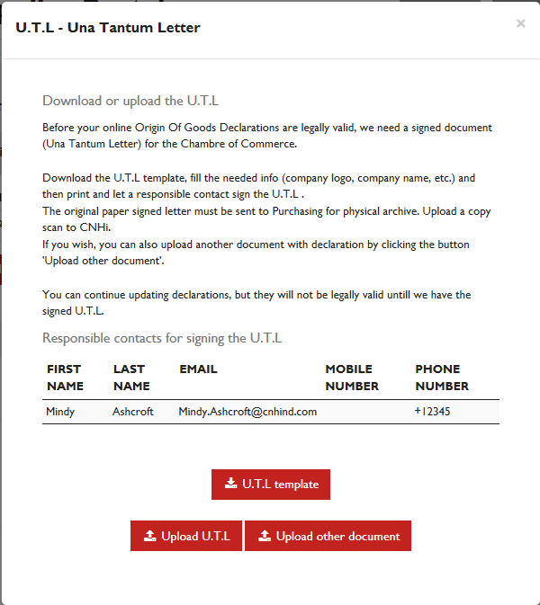
Check the text; refer to the mailbox ?
CHANGE : add a NOT NOW button (in the current version close the screen to continue)

UTL template

Upload U.T.L. / Upload other document
This will goto your browser to select whatever document from your drives to be uploaded.

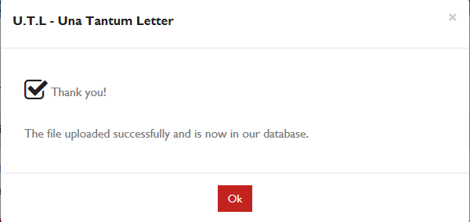

After uploading the user is presented with the list of active parts.

Declaration overview
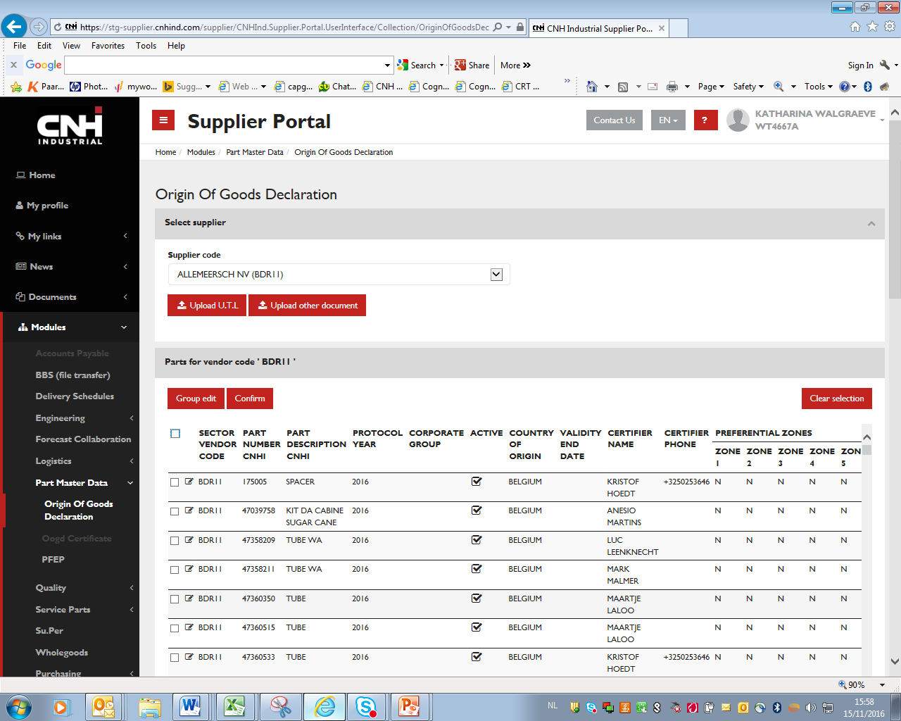
Active parts mean :
- for AG/CE the parts as present in delivery schedules for the supplier combined with WPS data
- for CV/PT the parts as send via an interface from IF3 and PS based on last 12 months receipt information
The system will know the translation of the harmonized code in the dropdown box to the segment code as how the system receives it from IF3, Powersap or WPS, so with the harmonized code will present all partnumbers requested declarations by all segments.
For the supplier it will be transparent as to for which segment he is filling in the data. The supplier will know for which legal entity he is filling data by the Gruppo Societario (info not available for AG/CE). A supplier may declare different origin on the same part number to different Legal entity (gruppo societario) and type (direct materials or spare parts, included in the Gruppo Societario).

Therefore sending back the information to the different segment systems will be based on respective updates done for the segment vendorcodes. (scheduled job).
The backend systems of CV and PT need to make sure that the information that is send in the interface is :
- Limited to the partnumbers for which declaration is needed (open order + 12 month movements registered) yearly job that sends all in 1 interface; the ones not in the interface but in the dataset need to be FLAGGED as non active any more, the others are updated.
- The non active ones will then be removed from the screen to the supplier and only the active ones are shown, where the supplier can switch the active flag to non active.

The backend system of AG/CE is WPS in relationship to schedules from MF, limiting the list of parts to the actively required parts by the plants.
CHECK SYSTEM : If more than N (-> TBD) rows are selected, it will be possible to navigate through result pages.
All functionality to do updates on the portal by internal users are also valid for supplier users.

Log of changes
At any time during the year, the user (external from the portal or internal from Purchasing System) , may modify data to declarations already provided during the current year or for next year (OOGDs of past years cannot be modified anyway).
The Purchasing Portal will log the changes in an audit trail (who changed what when) , but will not show a history of changes; it will only show the most recently data entered either via portal or backend system. If internal users changed data on the legacy system, of course those changes cannot be in the logging audit trails of the portal.

Proposed process new suppliers
- Buyer process :
  - The buyer finds out the correct contacts (not only for COO)
  - The buyer fills in the initial COO information in the purchasing systems
  - The buyer informs the supplier on usage of the CNH INDUSTRIAL SUPPLIER PORTAL
    - The buyer invites the supplier to fill in necessary documents including the UTL letter for COO

Administration
- users need to be properly mapped to the correct vendorcodes
- users need to have the OOGD COMPILER role (functional groups)

Technical analysis

WPS AG/CE : keep current table in database; no protocols, only updates of data
IVECO/CV (IF3 / Powersap) INFO :
- separate table with system indication where data is coming from
- protocol nbr ID is KEY in SAP and cannot be removed we store it as attribute, not as key
- protocolnbr is different for each year, but year is logical key, so with the year in SAP they can find the protocolnbr protocolnbr not needed for the portal to keep track and send back to SAP
- yearly process in November :
  - requests to start declarations for next year but also still need to receive current year for rest of the year (new parts); so for November/ December 2 records for the part key info, one for current protocol year and one for next year
  - make sure we can visualize previous years business decides when to delete, but we should keep to current and next year as basis visualization and only show previous years via a "button"
  - only for non OBSOLETE parts (obsolete parts will be in the database and could be extracted on request but not visualized on the portal)
- 20 preferential zones to be foreseen in interface, not necessarily on the screen, to be ready for evt future changes
- SAP will send annual cleanup (like initial load), to remove the parts that do not have had receipts in last 12 months and daily updates of new created parts (in header D or Y) flag the parts that are NOT in the interface based on the logicial key (vendor, grupo soc, part) for all protocol years (will normally be the previous protocol year only)
- The daily job updates the records and inserts evt new records (new vendor/parts added), but will not do the check on OBSOLETE parts (daily jobs should normally only ADD records, but could be used for UPDATES so that yearly process job only checks on obsolete parts)
- The yearly job will do the check on OBSOLETE parts
- Validity year in this case is based on PROTOCOL year + 1; supplier can enter either PROTOCOL year as validity year or PROTOCOL year +1 as 31/12/YYYY
- CERTIFIER load as CONTACT as well
GRUPPO SOCIETARIO :

Purchasing system | Gruppo Societario | Società  (Legal Entities) | Descrizione  (Legal Entities) | Diretti / Ricambi | Plants
SapIF3 | 13 | G021 | G021 IVECO S.P.A. | D | Brescia, Suzzara, Villanova, Villanova CKD
SapIF3 | 14 | G031 | G031 ASTRA VEICOLI INDUST. SPA | D | Astra Direct
SapIF3 | 15 | G212 | G212 FPT | D | Torino, Torino NEF, Foggia, Foggia Motori, Pregnana
SapIF3 | 16 | G022 | G022 IVECO PEGASO SL | D | Madrid, Valladolid
SapIF3 | 17 | G144 | G144 IVECO FRANCE SA | D | Annonay
SapIF3 | 19 | G024 | G024 IVECO MAGIRUS AG | D | Ulm
SapIF3 | 21 | G099 | Iveco Czech Republic a.s. | D | Vysoke Myto
SapIF3 | 22 | G794 | IVECO DEFENCE VEHIC. SPA | D | Bolzano
SapIF3 | 43 | G021 | G021 IVECO S.P.A. | R
SapIF3 | 44 | G031 | G031 ASTRA VEICOLI INDUST. SPA | R | Astra Ric
SapIF3 | 45 | G212 | G212 FPT | R | Pregnana ric
SapIF3 | 46 | G022 | G022 IVECO PEGASO SL | R | Madrid Ric, Valladolid Ric
SapIF3 | 47 | G144 | G144 IVECO FRANCE SA | R | Trappes
SapIF3 | 49 | G024 | G024 IVECO MAGIRUS AG | R | Ulm Ric
SapIF3 | 50 | G029 | G029 IVECO UK LTD | R | Winsford RIC
SapIF3 | 51 | G099 | Iveco Czech Republic a.s. | R
PowerSAP | 30 | - | FPT Powertrain Technologies France S.A. | D

LOGIC explained :
- Protocol year: it is generated by SAPs and it represents the year of competence of that protocol.
  - If we are during our annual procedure in Nov of year X, the protocol year will be X+1 (annual procedure nov 2016, protocol year 2017)
  - If we are during the year (X+1) and we have a new open order for a new part number, SAPs will generate a new protocol and the protocol year will be of that year X+1 (new protocol generated in the daily procedure the 13th march 2017 -> protocol year 2017)
So, when a protocol is generated it has a specific protocol year and the protocol year can not change during the life of that protocol number -> for SAPs is a key.
So in SAPs we cannot update the protocol year.
Also, considering that in CSCN side you don’t manage the protocol number, we think it is mandatory for you to manage the protocol year as a key otherwise you can not manage this kind of situation: we are in 01/11/2017 and CSCN has a specific PN/Supplier/gruppo societario with protocol year 2017 with validity end date 31/12/2017. In 02/11/2017 SAPs run the annual procedure for 2018 and because that PN/Supplier/gruppo societario is expiring, we generate a new protocol with year 2018 and we will send it to CSCN. In that moment, for the same PN/Supplier/gruppo societario you have 2 rows on CSCN, one related to 2017 (because the supplier between nov and dec can still change its declaration related to that protocol year) and the other one related to 2018 (because the supplier can start answering for the following year).
We both need to manage correctly the protocol year and SAPs need the correct protocol year back otherwise we can not match it to the right protocol and we can not guarantee the correct management and historicizing and printing.
- 2 year validity: the validity can be the protocol year or the protocol year +1.
So if SAPs in Nov 2016 (annual procedure) or in any day during daily procedure of 2017 generate a protocol with protocol year 2017 , its validity can be until 31/12/2017 or 31/12/2018.
- Validity end date: in the interface SAPs -> CSCN we may not set a default validity end date. We can just send to CSCN a blank field. But this field for SAPs is mandatory when we receive the interface from CSCN, because we will use it during the annual procedure to understand which new protocols need to be created and which protocols are still valid (because end validity date is in the future. This means that in CSCN you need to implement some checks on that field both when a supplier is giving a certification and both when CSCN is creating the interface for SAPs. And the checks must also guaranteeing that the only available dates are 31/12/protocol year or 31/12/protocol year+1
- Annual procedure: during the annual procedure SAPs will perform a check on the end validity date to verify which protocol must be created because in expiring and which protocols can be maintained for the following year.
This is what we will do for example in the annual procedure in Nov 2017:
- SAPs will generate a new protocol for the new part number/suppliers/gruppo societario
- SAPs will generate a new protocol for the part number/supplier/gruppo societario which are expiring in 31/12/2017
- SAPs will send to CSCN the same protocols with original protocol year (2017) for the part number/supplier/gruppo societario which are expiring in 31/12/2018
- CSCN needs to flag parts as DELETED that are NOT in the interface based on key PROTOCOL YEAR, VENDOR, PART, GRUPPO SOC after that delete all records of which protocol year < current year in the YEARLY process

Appendix

Glossary of Terms
Term | Definition

Additional supporting / reference documentation

